(D1) 4-Layers vs. OSI 7 Layers – a comparison
Introduction - The 4-layer structure of TCP/IP is built as information is passed down from applications to the physical network layer. When data is sent, each layer treats all of the information it receives from the upper layer as data, adds control information (header) to the front of that data and then passes it to the lower layer. When data is received, the opposite procedure takes place as each layer processes and removes its header before passing the data to the upper layer.
The 7 layer system can be considered the basis of network protocol structure but it is not rigid so that subsequent interpretations of protocol structures have been modified such as the TCP/IP or 5/4 layer models have combined or re-structured where protocols fit and therefore how data is moved between networks.
The obvious difference being the merging of some of the OSI layers in order to simplify the whole protocol model.
 | The TCP/IP 4-layer model | OSI - 7 Layers Model
Layer 1 | Application Layer  The Application Layer in TCP/IP groups the functions of OSI Application, Presentation Layer and Session Layer. Therefore any process above the transport layer is called an Application in the TCP/IP architecture. In TCP/IP socket and port are used to describe the path over which applications communicate. | Application Layer  - Defines interface-to-user processes for communication and data transfer in network  - Provides standardized services such as virtual terminal, file and job transfer and operations
Layer 2 |  | Presentation Layer  - Masks the differences of data formats between dissimilar systems  - Specifies architecture-independent data transfer format  - Encodes and decodes data; encrypts and decrypts data; compresses and decompresses data
Layer 3 |  | Session Layer  - Manages user sessions and dialogues  - Controls establishment and termination of logic links between users  - Reports upper layer errors
Layer 4 | Transport Layer  In TCP/IP architecture, there are two Transport Layer protocols. The Transmission Control Protocol (TCP) guarantees information transmission. The User Datagram Protocol (UDP) transports datagrams without end-to-end reliability checking. | Transport Layer  - Manages end-to-end message delivery in network  - Provides reliable and sequential packet delivery through error recovery and flow control mechanisms  - Provides connectionless oriented packet delivery
Layer 5 | Network Layer  (IP) is the primary protocol in the TCP/IP Network Layer. All upper and lower layer communications must travel through IP as they are passed through the TCP/IP protocol stack. There are many supporting protocols in the Network Layer, such as ICMP, to facilitate and manage the routing process. | Network Layer  - Determines how data are transferred between network devices  - Routes packets according to unique network device addresses  - Provides flow and congestion control to prevent network resource depletion
Layer 6 |  | Data Link Layer  - Defines procedures for operating the communication links  - Frames packets  - Detects and corrects packets transmit errors
Layer 7 | Network Access Layer  In the TCP/IP architecture, the Data Link Layer and Physical Layer are normally grouped together to become the Network Access layer. TCP/IP makes use of existing Data Link and Physical Layer standards rather than defining its own. | Physical Layer  - Defines physical means of sending data over network devices  - Interfaces between network medium and devices  - Defines optical, electrical and mechanical characteristics
 | 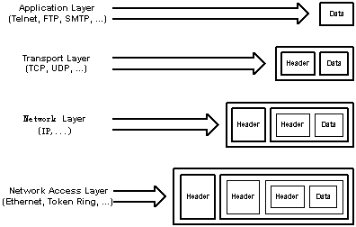 | 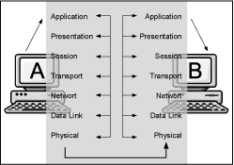
Summary – There is a need to simplify the data flow process because there are so many different networks in use. The Internet needs this flexibility in protocol structure in order for these many networks to be able to share data. The critical element is the accurate addressing of packets which defines how the data is transported. Confusingly there are two TCP/IP models a 4 and a 5 step model but don’t let that confuse you it is evidence that the protocol structure is a developing concept.

